**HR ANALYTICS DASHBOARD DOCUMENTATION**

**Project Title:**

HR Analytics Dashboard Using Power BI

**About The Project:**

This HR Analytics Dashboard is designed to provide comprehensive insights into employee attrition patterns within an organization. By leveraging Power BI for data visualization, it enables HR managers and decision-makers to analyze key factors influencing employee turnover, including demographic trends, job satisfaction, and business travel patterns. The dashboard uses an HR dataset containing attributes such as employee demographics, job roles, marital status, years of service, and education levels.

The primary goal is to offer actionable insights to optimize workforce management and reduce attrition.

**Technologies used:**

**Excel:** Used for initial data cleaning and preparation.

**Power BI:** Used to create interactive visualizations and dashboards.

**Steps Overview:**

1. **Data Collection:** The dataset includes multiple employee-related attributes, such as age, gender, education, monthly income, job satisfaction, and attrition rates.
2. **Data Understanding:** The data was analyzed to identify key metrics for visual representation.
3. **Data Transformation:** Column like Attrition is converted to numerical.
4. **Data Visualization:** Power BI was used to create an interactive dashboard that includes charts, graphs, and key performance indicators (KPIs).

**Dashboard Overview:**

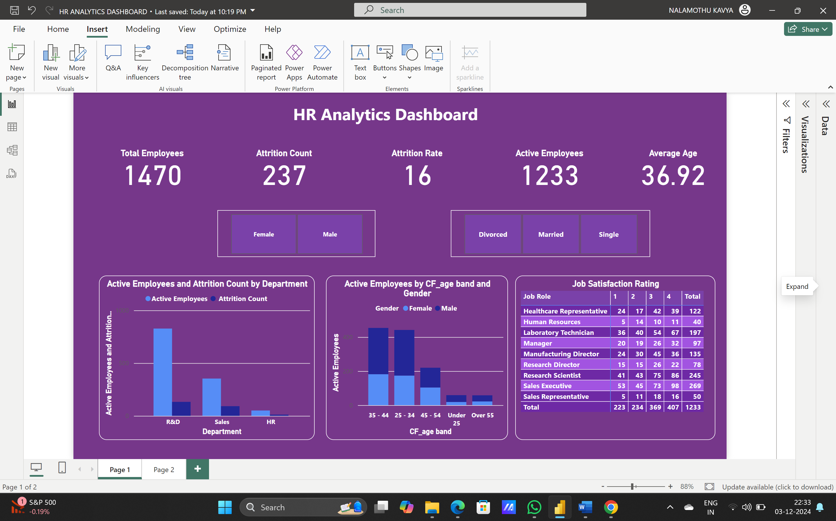

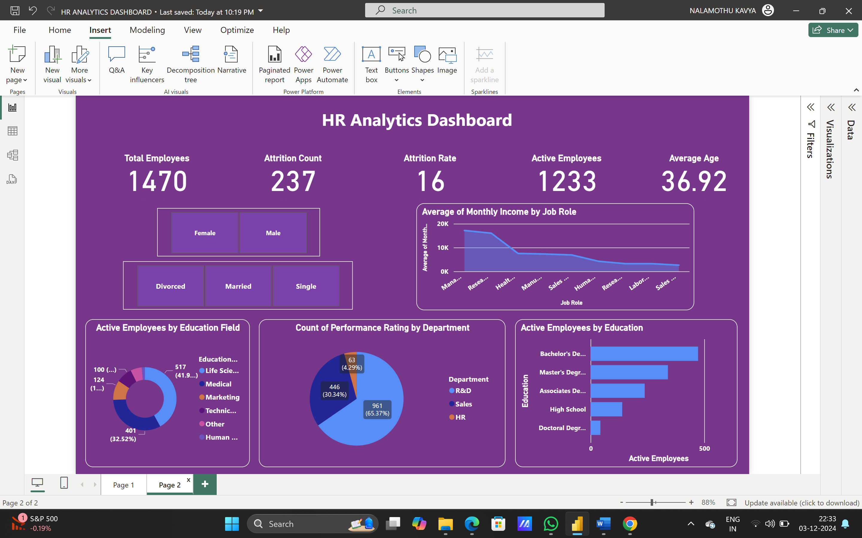

**Page 1- General Overview And Demographics:**

**Key Performance Indicators (KPIs):**

**Total Employees:** Displays the total workforce count, i.e., 1,470 employees.

**Active Employees:** Represents the current number of employees (1,233).

**Attrition Count:** The total number of employees who left the organization is 237.

**Attrition Rate:** Indicates the percentage of attrition, which is 16.

**Average Age:** Shows the average age of employees, calculated as 36.92 years.

**Visualizations and Insights:**

1. **Active Employees And Attrition Count By Department:**

At 828, R&D had the highest Active Employees and was 1,523.53% higher than HR, which had the lowest Active Employees at 51.

A vertical bar chart highlights attrition across various departments.

R&D has the highest attrition count (133 employees), followed by Sales (92 employees).

HR had the lowest attrition count (12 employees).

1. **Active Employees By CF_Age Band And Gender:**

Total Active Employees was higher for Male (732) than Female (501). 35 - 44 in Gender Male made up 22.06% of Active Employees. Average Active Employees was higher for Male (146.40) than Female (100.20). Active Employees for Male and Female diverged the most when the CF_age band was 25 - 34, when Male were 94 higher than Female**.**

1. **Job Satisfaction:**

The matrix shows the job satisfaction and active employees in the respective job roles.

**Page-2:**

1. **Average Of Monthly Income By Job Role:**

At 17,181.68, Manager had the highest Average of Monthly Income and was 554.29% higher than Sales Representative, which had the lowest Average of Monthly Income at 2,626.00. Across all 9 Job Role, Average of Monthly Income ranged from 2,626.00 to 17,181.68.

1. **Active Employees By Education Field:**

Life Sciences accounted for 41.93% of Active Employees. HR accounted for 1.62% of Active Employees

1. **Count Of Performance Rating By Department:**

The department R&D has highest performance rating when compared to sales and HR. It encounters 65.37% .

1. **Attrition Rate By Education:**

High School education has highest attrition rate that is 18 and the lowest attrition rate is for Doctoral Degree that is 10.

**Suggestions To Reduce Attrition:**

Conduct surveys or interviews to understand the specific issues leading to attrition. For instance, identify if it's related to workload, leadership, growth opportunities, or other factors causing dissatisfaction.

Develop strategies such as career development paths, skills training, or mentorship programs tailored to address the unique needs and career aspirations.

For reduced attrition among employees company could provide options like flexible work, career development programs, and initiatives promoting work-life balance.

The company could provide comprehensive onboarding, mentorship, and regular feedback mechanisms for new employees to acclimate well and feel valued within the company, reducing early attrition.

**Conclusion:**

This HR Analytics Dashboard serves as a critical tool for HR managers, enabling them to:

Identify patterns of employee attrition by department, role, and demographics.

Develop data-driven strategies to improve employee engagement, retention, and workforce management.

By leveraging the insights provided, HR teams can address key challenges, optimize employee satisfaction, and strengthen organizational performance.